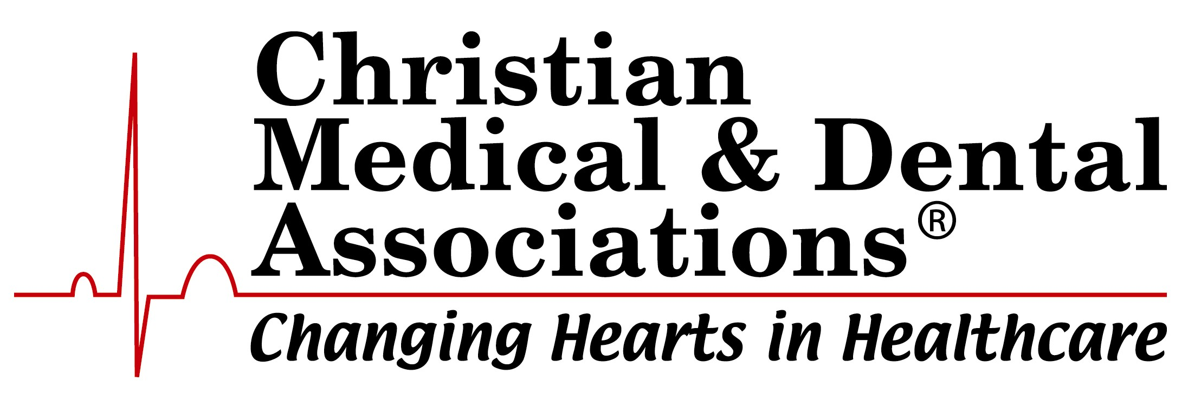
2020 Servant of Christ Award

Dr. T. Bob Davis

“Praise the Lord!... Praise him with trumpet sound; praise him with lute and harp! Praise him with tambourine and dance; praise him with strings and pipe! Praise him with sounding cymbals; praise him with loud clashing cymbals! Let everything that has breath praise the Lord!” (Psalm 150, ESV).

Established in 1972, the Servant of Christ Award honors those whose careers exemplify commitment to medical excellence along with a stalwart faith in Jesus Christ. The Christian Medical & Dental Associations is honored to present the 2020 Servant of Christ Award to Dr. T. Bob Davis.

T. Bob has had a personal relationship with Jesus since he was a pre-teen, which was a basis for some extraordinary spiritual encouragement and support through his church family, his community friends and his own family. His wife Janis grew up in a Christian family as well, and they were actively involved in their local church. Both enjoyed playing the piano and singing for church and community.

As natives of Alabama, T. Bob and Janis first met while he was a dental student at the University of Alabama Dental School. He graduated with his Doctorate of Dental Medicine in 1967, served as Captain in the U.S. Air Force and then married in Birmingham, Alabama in November 1969. That began their life together in Dallas, Texas, where they have lived, raised their family and joyfully served the Lord.

Having practiced dentistry for more than 53 years, T. Bob is highly respected in the dental profession, not only locally and statewide but also nationally and internationally, as noted by inclusion in fellowship in the four national and international dental honor organizations. He is one of only just over 3,000 dentists in the U.S. who have attained the distinction as Master in the Academy of General Dentistry, which represents a strong practice-long commitment to continuing dental education, quality care and leadership.

As a four-time Dallas Dentist of the Year, he has been nominated four times for Texas Dentist of the Year and served as the 2014 Texas Dentist of the Year. He has been interviewed by numerous magazines, newspapers and television shows as the spokesperson for national dental organizations, has served as Secretary of the Board of Trustees of Southwestern Baptist Seminary and was selected chairman of two dental conventions in Texas. Leadership roles include President of the Academy of Dentistry International, an honor society.

In addition to his contributions to the world of dentistry, Dr. T. Bob is a pianist extraordinaire who has traveled extensively throughout the world as a piano soloist and accompanist for large youth choirs and large dental and Southern Baptist conventions, as well as concerts of his own. His unique and flamboyant stylings are signature with the hymn and inspirational music settings. His 13 piano recordings have spanned over 50 years of concerts and have been played on radio stations throughout the U.S. and even on satellite and stations overseas. For decades he served as a pianist for First Baptist Church, Dallas, and Prestonwood Baptist Church in north Dallas.

Janis volunteered T. Bob for his first dental mission trip as a result of serving as youth sponsors on national and international youth choir concert tours. Since then, he has served as leader of dental mission trips for more than 44 years to Mexico, Nicaragua, India and Guatemala. Through these trips, he has been a mentor to more than 1,500 dental students, 500 staff and 500 dentists, giving most of them their first dental mission trip experience. The American Dental Association named him Humanitarian of the Year in 2018 (one of the top two awards annually), which was followed by being named the International College of Dentists’ Humanitarian in 2019.

T. Bob also served a total of 45 years as a youth worker in college/dental school and following in Dallas in both churches through the years where he was also a deacon. His support of youth singing led him to inspire a number of youth to sing their very first song, with several going on to be musicians and ministers of music. One recently retired after 25 years as a leading bass/baritone for the Metropolitan Opera Company in New York City. Supporting gospel pianists and singers and investing in others’ spiritual lives comes natural to him. Many of those he helped raise up spiritually still stay in touch seeking encouragement and prayers through the years.

Ministry through the piano medium is a natural talent given by our heavenly Father to T. Bob, a talent he has polished and refined to inspire folks young and old alike toward the love of Jesus. His signature smiling while looking at the audience and playing a dynamic worship song has endeared him to thousands in audiences in church, concert and convention settings. In fact, he has served as the pianist for CMDA’s National Convention on two occasions. His signature hymn arrangements draw people heavenward and toward a personal relationship with our heavenly Father. Despite the accolades of both the dental field and the piano world, T. Bob is just at home in the big crowds as in the small settings of one-on-one. His talent is God given while his focus is to share the Good News in his lifetime. Service to others has been a lifestyle while mentoring others has been a result. In all contacts, he seeks to radiate his faith in Jesus Christ.

Throughout his career in dentistry and ministry through music, Janis enthusiastically encouraged and supported her husband, traveling with him throughout the nation and overseas. T. Bob and Janis have three grown children and seven grandchildren, all Christlike who live within a 30-minute drive of their home. This makes for lots of opportunities to spend time with them and help mold them spiritually. Janis at several junctures in time pointed T. Bob into the next big opportunity in God’s will; a true helpmate and companion!

In recognition of a life focused on serving God no matter where His call leads, and to acknowledge his unparalleled service and leadership within CMDA, we proudly present the 2020 Servant of Christ Award to Dr. T. Bob Davis.

